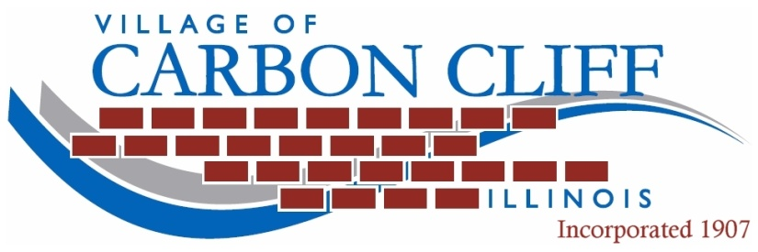
Bill Hintz – Village President
Karen L. Hopkins – Village Clerk
Nick Gottwalt – Village Director
(309) 792-8235

1001 Mansur Avenue - P.O. Box 426 - Carbon Cliff, Illinois 61239 www.Carbon-Cliff.com

Chairman
Alma Neels

Trustee
Robert Dreher

Trustee
Larry Scott
PUBLIC SAFETY COMMITTEE MEETING

Monday, May 13, 2019, at 7:00 P.M.
Village Hall – 1001 Mansur Avenue, Carbon Cliff

AGENDA

- Update on Monthly Calls from the Rock Island County Sheriff’s Department.

- Discuss Ordinance on “Abatement of Chronic Nuisance Properties”.

- Monthly MUNICES Report – April 2019.

- Monthly Maintenance Comp Time Report – April 2019.

- Monthly Clerk’s Report – April 2019.

- Monthly Treasurer’s Report – April 2019.

- New Business / Other.

Next Meeting – Monday, June 10, 2019 – 7:00 P.M. at 1001 Mansur Avenue
(FIRE, POLICE, HEALTH, PLANNING, ZONING, INSPECTIONS AND CIVIL DEFENSE)

